Written Addition- Answers

Key Stage 2: 2003 Paper A
1.
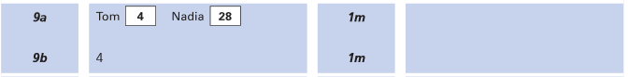
Key Stage 2: 2003 Paper B
1.
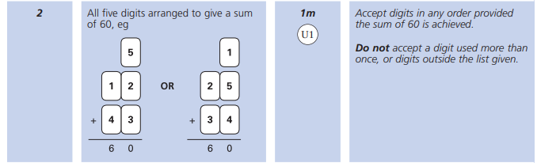
Key Stage 2: 2005 Paper A
1.
Key Stage 2: 2005 Paper A
2.
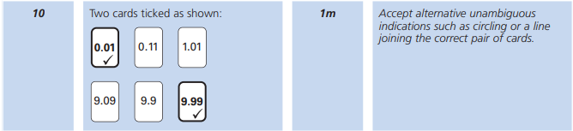

Key Stage 2: 2005 Paper B
1.
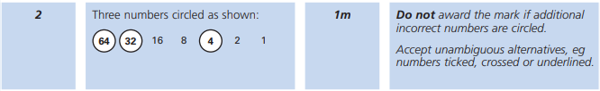
Key Stage 2: 2006 Paper A
1.
Key Stage 2: 2007 Paper A
1.
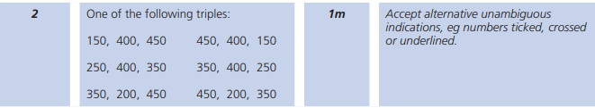
Key Stage 2: 2008 Paper A
1.
Key Stage 2: 2011 Paper A
1.
Key Stage 2: 2013 Paper B
1.
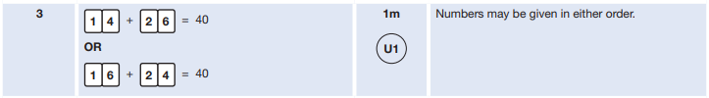

Key Stage 2: 2014 Paper B
1.
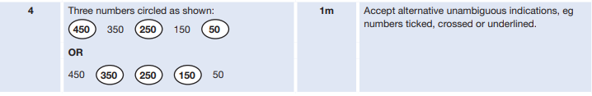
Key Stage 2: 2015 Paper A
1.
Key Stage 2: Paper 1 Arithmetic - Sample
1.
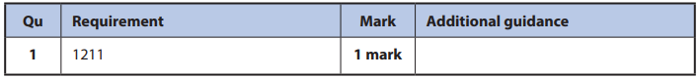
Key Stage 2: 2016 Paper 1 Arithmetic - Sample
1.
Key Stage 2: 2016 Paper 1 Arithmetic - Sample
2.
Key Stage 2: 2016 Paper 1 Arithmetic - Sample
3.
Key Stage 2: 2016 Paper 1 Arithmetic - Sample
4.
Key Stage 2: 2016 Paper 1 Arithmetic - Sample
5.
Key Stage 2: 2016 Paper 3 Reasoning - Sample
1.
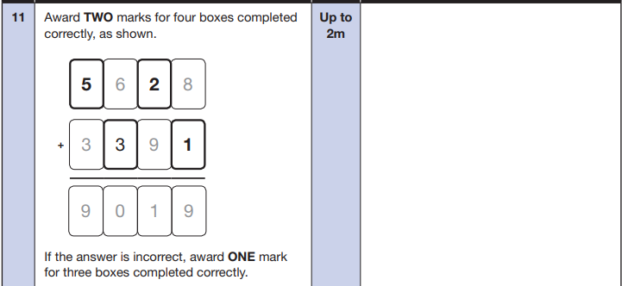
Key Stage 2: 2016 Paper 1 Arithmetic
1.
Key Stage 2: 2016 Paper 1 Arithmetic
2.
Key Stage 2: 2016 Paper 1 Arithmetic
3.
Key Stage 2: 2016 Paper 1 Arithmetic
4.
Key Stage 2: 2016 Paper 1 Arithmetic
5.

Key Stage 2: 2016 Paper 1 Arithmetic
6.
Key Stage 2: 2016 Paper 2 Reasoning
1.
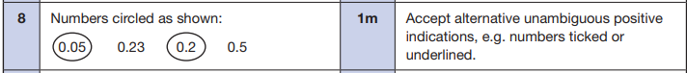
Key Stage 2: 2017 Paper 1 Arithmetic
1.
Key Stage 2: 2017 Paper 1 Arithmetic
2.
Key Stage 2: 2017 Paper 1 Arithmetic
3.
Key Stage 2: 2017 Paper 1 Arithmetic
4.

Key Stage 2: 2017 Paper 2 Reasoning
1.
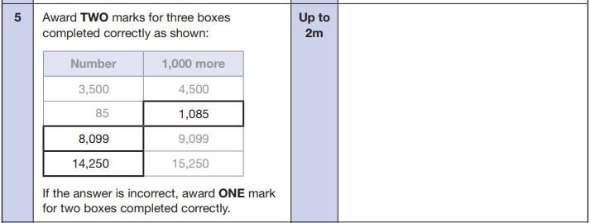
Key Stage 2: 2018 Paper 1 Arithmetic
1.
Key Stage 2: 2018 Paper 1 Arithmetic
2.
Key Stage 2: 2018 Paper 1 Arithmetic
3.
Key Stage 2: 2018 Paper 2 Reasoning
1.
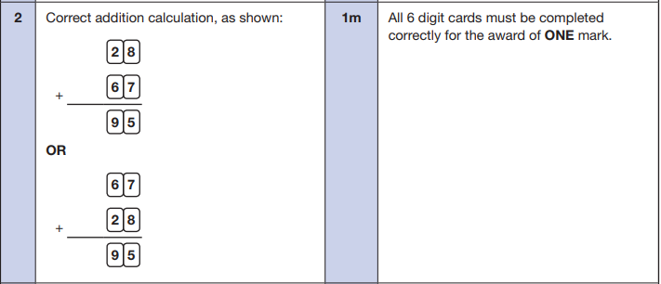
Key Stage 2: 2019 Paper 1 Arithmetic
1.
Key Stage 2: 2019 Paper 1 Arithmetic
2.
Key Stage 2: 2019 Paper 1 Arithmetic
3.
Key Stage 2: 2019 Paper 1 Arithmetic
4.
Key Stage 2: 2019 Paper 1 Arithmetic
5.

